Project Proposal On

**Departmental Store Management System**

Computing Project

Level 5 Diploma in Computing

Softwarica College of IT & E-Commerce

Dillibazar, Kathmandu, Nepal

12th April, 2019

Submitted by: Submitted to:

Prashant Gharti Magar Niman Maharjan

00169995 Module Leader

Table of Contents

**Type chapter title (level 1)1**

Type chapter title (level 2)2

Chapter 1: Introduction2

Background of the project2

Problem Statement2

Features2

Overview of the Project3

Chapter 2: Scope of the Project3

Limitations3

Aims3

Objectives3

Overview of the Scope4

Chapter 3: Development Methodology4

Development Methods4

Design Patterns5

System Architecture6

Chapter 4: Project Plan6

Work Breakdown Structure6

Milestones7

Scheduling8

Chapter 5: Risk Management10

Chapter 6: Configuration Management11

Chapter 7: Conclusion12

Chapter 8: Reference and Bibliographies13

# Chapter 1: Introduction

Departmental Store Management System (DSMS) is the desktop-based application which helps to manage inventory and sales of department stores. It will be also able to record details of customer and their purchases and also prepare receipt for customer upon sales. One should be able to track current condition of product stocks and also help decide whether purchase to fill up the goods before they are too low or not and how much based on sales statistics. System will be designed and developed in .Net Framework using C# Programming Language and SQL Server 2014 for database.

## Background of the project

Department stores are well-renowned shopping centres which provide wide ranges of products like food, wears, cosmetics, appliances, etc of multiple brands under the same roof. Products are organised in different departments or categories depending on size of store. This project is aimed for such stores to develop system/ application which will help manage record of purchases and sales as well as status of product stocks efficiently.

## Problem Statement

In Departmental store, thousands to millions of products of wide range of variety are stocked for sales. Similarly, thousands to customers visit department store daily for shopping. This makes store manager very difficult to manage and keep track of products and customers. Furthermore, it is almost impossible to track any missing product and their situation in case of loss or theft. Thus, in this project it will be made feasible to add all products in the store to inventory of system and remove the products that sold with details to whom it was sold. This will be able to solve the prevalent issue.

## Features

1. Interface for adding products to stocks, update its details and remove items from stocks upon sale
2. Point of Sale (POS)system for sales
3. Record customer details
4. View sales record and can be searched by date or customer name
5. Create, edit and delete user accounts
6. Login based on user account, password and account type: admin permitted for managing overall system and normal user for managing point of sales (POS)
7. Back up and data storage in database.
8. Print sales receipt

## Overview of the Project

For best productivity of business in departmental stores, records of every product and their current condition, customer details with their shopping preference and sales of product have to be kept. DSMS project will help to keep track all of them and help manage them. It will also be able to analyse customer choice of products and sales statistics that which products sales most and which ones less leading to better understanding of better ideas for business profit.

f

# Chapter 2: Scope of the Project

Department stores vary in size from small scale to large scale stores and they offer wide variety of products and services. Because of its huge scope and complexity, management system for department stores need extensive research and analysis, large budget and team of IT experts and long time period which isn’t possible as project is to be implemented individually in limited time. As such this project “Departmental Store Management System” is designed as simpler version especially suited for small scaled stores.

## Limitations of project

1. Limited to cash transactions only
2. Manual data entry and sales entry of products
3. Only suited to small scaled department stores
4. Offline system

## Aims

1. To manage and record sales transactions as well as inventory of department stores efficiently.
2. To ensure sufficient stocks of goods in store.
3. To ensure safety of goods from loss, theft, etc.
4. To analyse sales records and customer preferences for better business.

## Objectives

1. To carry out detailed analysis and also collect related data.
2. To design system based on the requirements and analysis.
3. To design a working database.
4. To implement system design into code.
5. To test developed system with various tools.
6. To prepare documentation for keeping track of the progress and overall completion report.

## Overview of the Scope

To be said in brief, overall scope for the project of management system for department store is huge and because of its complexity as well as due to lack of enough resources be it manpower of IT experts or time constraint or budget capacity or proper tools, this project is constrained to be a type of prototype for Departmental Store Management, a simpler one. It will still be able to employ needs of small department stores effectively.

# Chapter 3: Development Methodology

## Development Methods

For project to be successful, it needs to managed and planned well. Software Development Methodology is the structure or framework that is used for planning and controlling the process of developing information system. There are various methodologies suited for different types of software projects and scenarios with their own pros and cons. Waterfall Model is one of them. For this project, waterfall model will be used as development methodology because of the following reasons:

1. Waterfall model is suited for project in which all requirements are already clear and all requirements are already set for this project.
2. It is simple and concise suitable for small scaled project like this version of store management system.
3. It has step by step processes and each stage must be fully completed before moving forward into next one which helps to ascertain that previous tasks are completed successfully and free from errors.

Other methodology especially agile methodology need team to develop which is isn’t possible as current project needs to be done individually and also demand to have regular interaction with user/ customer while this project doesn’t have current designated customers and is to be submitted to module leader for academic purpose so waterfall is correct choice.

Steps taken in waterfall methodology is shown on figure below:

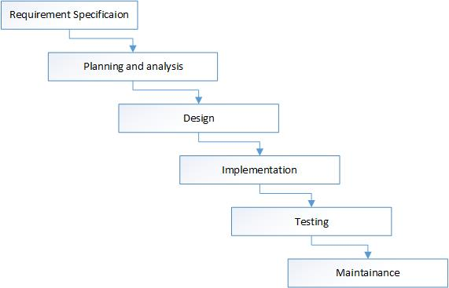

Figure 1: Waterfall methodology

## Design Patterns

Design patterns are general repeatable solutions to a commonly occurring problem in software design. [sourcemaking.com, 2019] They can help speed up development process, avoid occurrent issues that may result to major problems and also improve code readability for other familiar experts.

I am using MVC design pattern for the project. MVC is divided into three components: model, view and controller each responsible for separate tasks.

Model: Handles business logic

View: Responsible for presentation state of model to user

Controller: Allow user to interact with the model

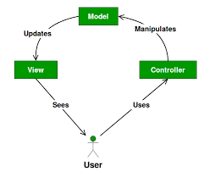

Figure 2: Design Pattern

## System Architecture

System Architecture is the conceptual model that describes the structure and behavior of the proposed or existing system. It consists of technical framework, user requirements, hardware components and software components to be used or used in system. Here in the project software architecture is emphasized.

Departmental Store Management System is being developed in Object-Oriented architecture.

In this architecture, system is divided into smaller components called class and works by interacting between those classes by using object. This project will be developed using following infrastructures:

1. C# (Programming Language)
2. .Net Framework (Programming environment with set of libraries)
3. SQL Server 2014(Software for designing Database)

# Chapter 4: Project Plan

## Work Break Down Structure

Work breakdown structure (or WBS) is a hierarchical tree structure that outlines your project and breaks it down into smaller, more manageable portions. [wrike.com, 2019] It helps to make project more manageable and also facilitates parallel work leading to better productivity in less period.

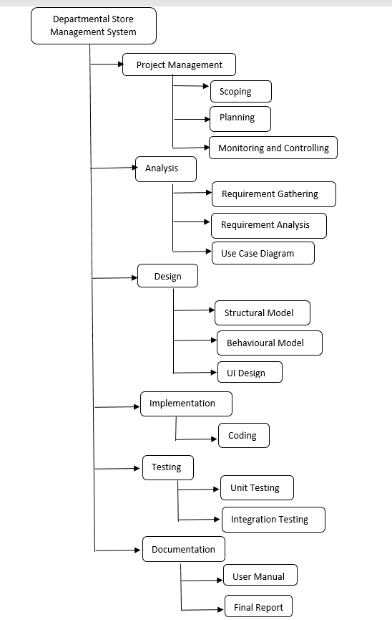

Figure 3: WBS structure of project

## Milestones

Milestones are tools used in project management to help in project scheduling and determine accurately whether project is on schedule or not.

|  |  |  |  |
| --- | --- | --- | --- |
| **Milestones** | **Start Date** | **End Date** | **No. of Days** |
| **Project proposal** | 25/03/2019 | 09/04/2019 | 18 |
| **Analysis specification** | 10/04/2019 | 07/05/2019 | 28 |
| **Design** | 08/05/2019 | 02/06/2019 | 25 |
| **Implementation** | 03/06/2019 | 22/06/2019 | 20 |
| **Testing** | 23/06/2019 | 29/06/2019 | 7 |
| **Documentation** | 30/06/2019 | 10/07/2019 | 11 |

Figure 4: Milestones table

## Scheduling

Scheduling is one of the important tools for project management. It will help project manager properly plan each tasks of project and its estimated completion time which not only makes process of developing project systematic and organized also it will remind developer of deadline to complete project in time.

Time Estimation

|  |  |  |
| --- | --- | --- |
| **Task Number** | **Task Name** | **Estimation Time** |
| 1. | Project management (Proposal) | 16 days |
| 2. | Analysis | 28 days |
| 2.1 | Requirement Gathering | 12 days |
| 2.2 | Requirement Analysis | 12 days |
| 2.3 | Use Case Diagram | 4 days |
| 3. | Design | 25 days |
| 3.1 | Structural Model | 10 days |
| 3.2 | Behavioural Model | 10 days |
| 3.3 | UI Design | 5 days |
| 4. | Implementation | 20 days |
| 4.1 | Coding | 20 days |
| 5. | Testing | 7 days |
| 5.1 | Unit Testing | 4 days |
| 5.2 | Integration Testing | 3 days |
| 6. | Documentation | 11 days |
| 6.1 | User Manual | 5 days |
| 6.2 | Final Report | 5 days |
| 6.3 | Report Submission | 1 day |
|  | Total Days | 108 days |

Figure 5: Time estimation table

For proper and systematic scheduling, Gantt chart was prepared. It is used to view time estimations for the project graphically. I have used Project Libre for making Gantt Chart. Project Libre is freeware project management software.

In the following Gantt Chart, systematic scheduling and time estimation of each tasks by breaking them into series of phases including milestones is done.

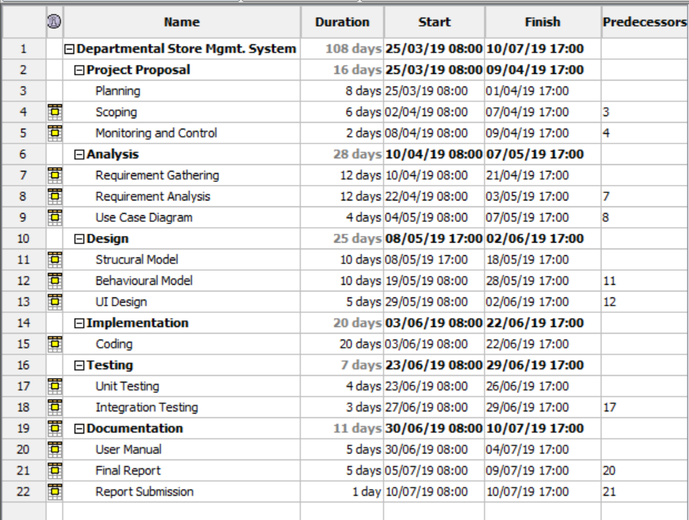

Figure 6: Gantt chart

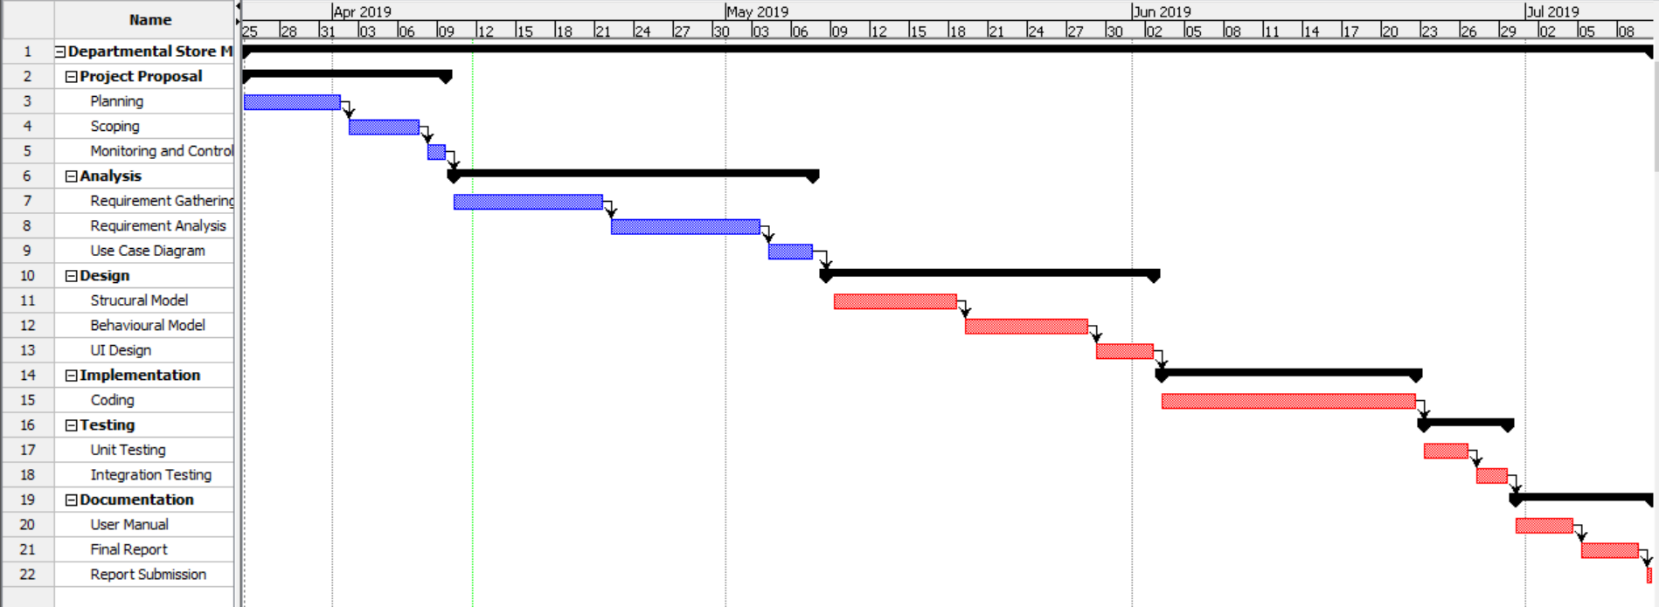

Figure 7: Gantt chart 2

# Chapter 5: Risk Management

In any project, risks always exist and cannot be avoided. But impact and effects due to the risk can be controlled and minimized. There are potential risk factors in our project too. Such potential risks with their likelihood, consequence, impact on the project and solutions to tackle or prevent them are illustrated in tables below:

|  |  |
| --- | --- |
| **Likelihood** | **Value** |
| Low | 1 |
| Medium | 2 |
| High | 3 |

Figure 8: Likelihood Table (Possible Occurrence of risk)

|  |  |
| --- | --- |
| **Consequence** | **Value** |
| Very low | 1 |
| Low | 2 |
| Medium | 3 |
| High | 4 |
| Very high | 5 |

Figure 9: Consequence Table (Bad effects caused by risks)

|  |  |  |  |  |
| --- | --- | --- | --- | --- |
| **Potential Risks** | **Likelihood(L)** | **Consequence(C)** | **Impact(L*C)** | **Action (Solutions)** |
| Machine failure | 1 | 5 | 5 | Backup data regularly,  Checkup system regularly for issues,  Replace or mend failure part as soon as possible |
| Natural Calamity | 1 | 5 | 5 | Data back system, fast re-installation of system |
| Power Supply Eruption | 2 | 3 | 6 | Use of UPS systems, Power backup system |

Figure 10: Risk Management table

# Chapter 6: Configuration management

Configuration management is an invaluable tool for providing control of the deliverables and avoiding mistakes and misunderstandings. [apm.org, 2019] It helps to handle changes to system in the way that it maintains integrity over the time. Files and folders related to project are arranged in the systematic to have easier access to them and also backup folder is kept to ensure data is recovered upon loss.

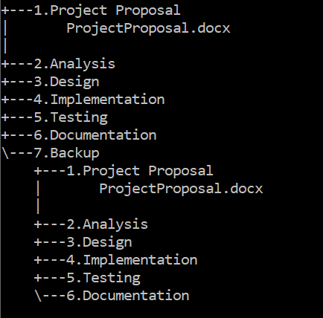

Figure 11: Command tree of project configuration

Project and its progress will be uploaded in **GitHub**. It will be helpful for both store, update and backup purpose. **GitHub** is the online platform which provides host, access control and collaboration features for open source software projects.

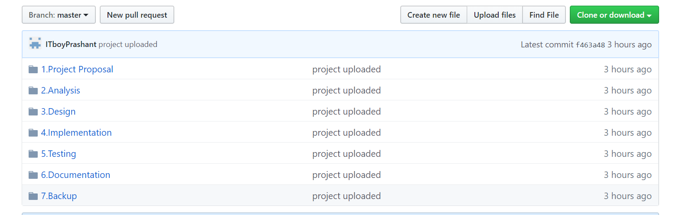

Figure 12: Folder and subfolders in GitHub account

# Chapter 7: Conclusion

Management system software is being developed for small scaled departmental store in this way. After completion of project, complete system will be able to store and record product data and customer data as well as information of sales and purchases effectively. Main manager will be able to add, update and remove products, manage sales information, carry out purchase, view logistics of customer and sales, etc. and sales person will be able to carry out sales of products via POS.

# Chapter 8: Reference and Bibliographies

Apm.org(2019).*Configuration Management* [online] Available from: <https://www.apm.org.uk/body-of-knowledge/delivery/scope-management/configuration-management/> [Accessed on: 7th April 2019]

Jamsheer, K.(2018)  *12 Best Software Development Methodologies With Pros And Cons* [online] Available from: <https://acodez.in/12-best-software-development-methodologies-pros-cons/> [Accessed on: 5th April 2019]

Sourcemaking.com (2019) *Design Patterns*[online] Available from: <https://sourcemaking.com/design_patterns> [Accessed on: 7th April 2019]

Trotter, C. (2017) *What is a department store?* [online] Available from: <https://www.insider-trends.com/what-is-a-department-store/> [Accessed on: 1st April 2019]

Wrike.com (2019) *What is Work Breakdown Structure in Project Management?* [online] <https://www.wrike.com/project-management-guide/faq/what-is-work-breakdown-structure-in-project-management/> [Accessed on: 4th April 2019]